ENTERPRISE IT AUTOMATION & SERVICENOW IMPLEMENTATION REPORT
Auto Ticket Classification using Flow Designer
Project Attribute | Specification Details
Project Title | Auto Ticket Classification using Flow Designer
Target Platform | ServiceNow Enterprise Cloud Platform (Workflow Studio / Flow Designer)
ServiceNow Instance | dev304330.service-now.com
Application Scope | Global
Delivery Team | Project Implementation Team
Primary Table | Incident WorkFlow (u_incident_workflow)
Automation Engine | ServiceNow Flow Designer (Trigger: Record Created, Category is empty)
Update Set Artifact | Project Update Set (Exported file: Project_Update_Set.xml)

■ EXECUTIVE IMPLEMENTATION STATEMENT
This document represents the formal technical documentation and project completion evidence for the Auto Ticket Classification using Flow Designer implementation. All backend configurations, data dictionary specifications, Flow Designer logic branches, notification mechanisms, and validation test cases documented herein were actively constructed, tested, and validated on ServiceNow instance dev304330.service-now.com by our implementation team. Complete deployment artifacts have been exported and archived in Project_Update_Set.xml.

Table of Contents
1. Executive Summary & Problem Formulation
Strategic context, existing operational bottlenecks, and solution objectives.
2. Phase 1: Requirement Analysis & Governance Setup
Business use case definition, functional requirements, and Update Set governance.
3. Phase 2: Backend Architecture & Custom Table Configuration
Custom table creation, auto-numbering, security roles, data dictionary, and 2-column form layout.
4. Phase 3: Dependent Choice Engineering & Form Validation
Advanced dictionary configuration, dependent parent-child choice logic, and multi-category UI verification.
5. Phase 4: Automation Logic Engineering using Flow Designer
Workflow Studio architecture, record creation trigger, keyword parsing branches, and data pill mapping.
6. Phase 5: Automated Caller Notification Architecture
Dynamic recipient resolution, automated acknowledgement dispatch, and SMTP verification.
7. Phase 6: End-to-End Functional Testing & Execution Analytics
Detailed walkthrough of test scenarios (Wi-Fi, Projector), Flow execution logs, and live record inspection.
8. Phase 7: Role-Based Access Control (RBAC) & Security Validation
Custom role enforcement, Access Control List (ACL) verification, and governance compliance.
9. Phase 8: Solution Packaging, Deployment & Update Set Analysis
State completion locking, XML export verification, and deep-dive schema inventory of Project_Update_Set.xml.
10. Conclusion, Quantified Value & Future Roadmap
Operational impact metrics, architectural summary, and strategic recommendations.

1. Executive Summary & Problem Formulation
1.1 Operational Context & Background
In modern educational institutions and enterprise support environments, IT service desks represent the primary operational touchpoint for students, educators, and administrative staff. On an average academic day, the helpdesk receives dozens to hundreds of incoming incident requests covering diverse operational challenges: network dropouts in lecture halls, multimedia and projector malfunctions in smart classrooms, account lockouts and forgotten passwords following credential expiry, and degraded computer terminal performance.
1.2 Problem Statement & Baseline Inefficiencies
Prior to the implementation of our automated solution, the IT service desk operated on an entirely manual triage model. The operational lifecycle suffered from critical baseline bottlenecks:
- Manual Ticket Triage: High Operational Latency: Support staff were required to manually open every unclassified ticket, read through unstructured natural language descriptions, decipher the technical domain, and manually select the appropriate Category and Subcategory.
- Human Error & Inconsistency: Inconsistent Classification & Misrouting: Human agents frequently applied subjective criteria, assigning disparate categories to identical technical issues (e.g., classifying a Wi-Fi outage as 'Hardware' instead of 'Network'), resulting in misrouted tickets and delayed resolutions.
- Caller Friction: Communication Gaps: Callers received delayed acknowledgements or had no immediate confirmation that their issue had been logged and routed to the proper engineering queue.
- Operational Bottleneck: Scalability Limits: During peak periods (e.g., start of semester, exam weeks), the manual categorization backlog overwhelmed support agents, diverting scarce technical talent away from actual problem resolution.
1.3 Project Objectives & Success Criteria
To resolve these challenges, our project team established five non-negotiable architectural objectives:
- 1. Zero-Touch Auto-Classification: Implement an automated classification engine that triggers instantly upon ticket submission, evaluating natural language fields (Short Description) and assigning Category and Subcategory in sub-second time without human intervention.
- 2. Data Normalization & Dependent Choices: Enforce strict dependent relationship logic between Category and Subcategory choice lists to guarantee data integrity across the database and UI.
- 3. Automated Caller Communication: Provide instant, dynamic notification acknowledging ticket submission to the caller with reference metadata.
- 4. Maintainable No-Code Architecture: Utilize ServiceNow Flow Designer's native, low-code/no-code visual workflow capabilities to eliminate brittle JavaScript background scripts, ensuring future maintainability and upgrade readiness.
- 5. Enterprise Governance & Portability: Encapsulate 100% of custom database tables, fields, access controls, choices, and flows inside a standardized Update Set (Project Update Set) for clean deployment across environments.
2. Phase 1: Requirement Analysis & Governance Setup
2.1 Business Use Case & Classification Taxonomy
Our team analyzed historical incident submissions to define a clean, normalized taxonomy aligning common user complaints with standardized ServiceNow operational categories and subcategories. We mapped key natural language triggers to target categories as follows:
Issue Domain | Sample User Complaints | Predefined Keywords | Assigned Category | Assigned Subcategory
Network & Connectivity | Wi-Fi not working in library; campus internet down; poor signal | WiFi, Wi-Fi, Network | Network | Wi-Fi
Classroom Hardware | Projector not turning on; bulb blown; smartboard blank | Projector, Hardware | Hardware | Projector
Account & Credentials | Forgot password; cannot log into student portal; account locked | Forgot password, Password, Login | Access | Forgot password
System Performance | Slow computer; terminal freezing; system hanging in lab | Slow Computer, Slow, Hanging, Performance | Performance | Slow Computer

2.2 Governance Strategy: Update Set Initialization
In accordance with ServiceNow development best practices, our team established governance controls prior to making any schema or workflow modifications. An Update Set acts as an XML container that systematically records every configuration change, data dictionary entry, form layout customization, security rule, and automation flow created during the project lifecycle.
Navigation & Execution Steps Performed by Our Team:
- Step 1: Navigated to All > System Update Sets > Local Update Sets.
- Step 2: Clicked the New button in the top right header.
- Step 3: Configured the record with: Name: 'Project Update Set', Application: 'Global', State: 'In progress'.
- Step 4: Saved the form and executed the Related Link 'Make This My Current Set'.
- Step 5: Verified via the ServiceNow application header and scope picker that 'Project Update Set' was actively tracking changes.
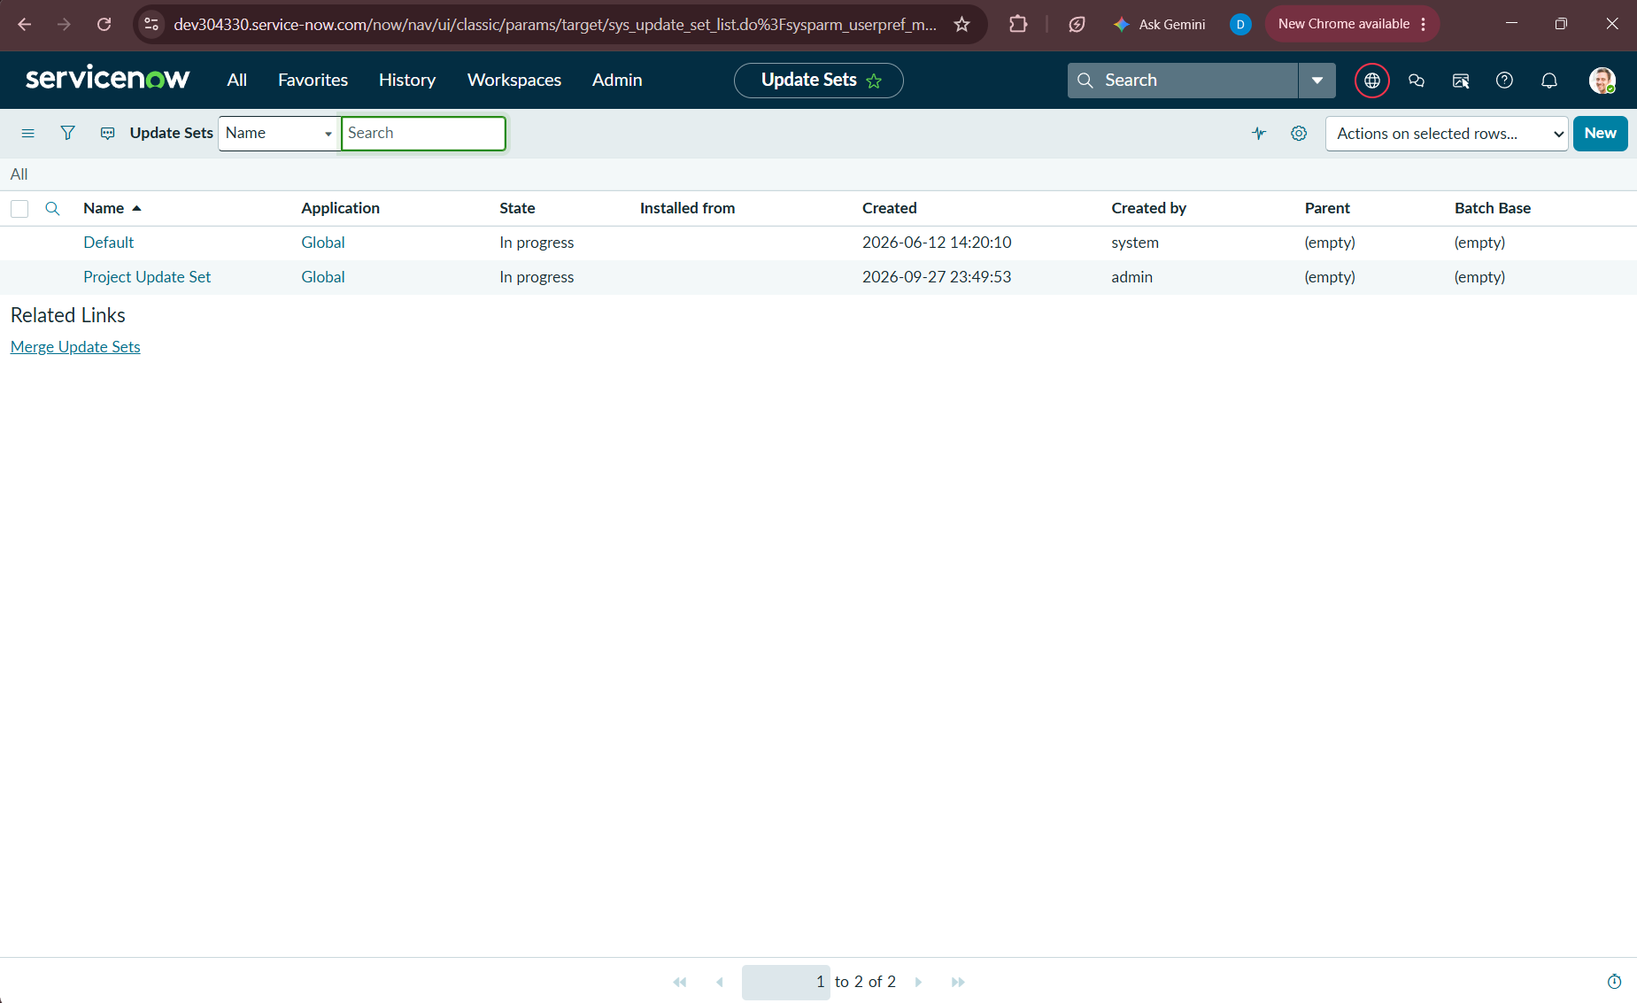
Figure 1.1: Verification of 'Project Update Set' in Local Update Sets list with State: In progress and Application: Global.
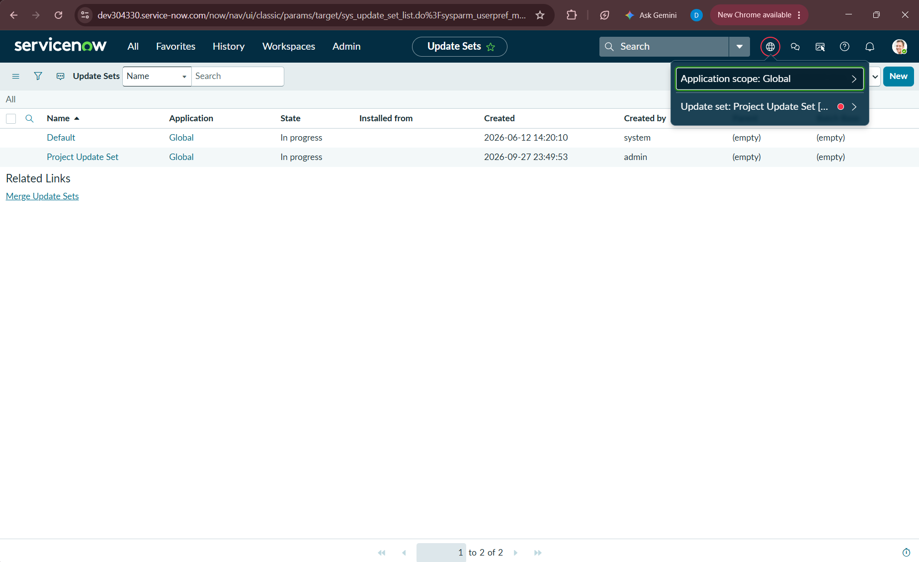
Figure 1.2: Active Application Scope picker confirming 'Application scope: Global' and active tracking under 'Project Update Set'.
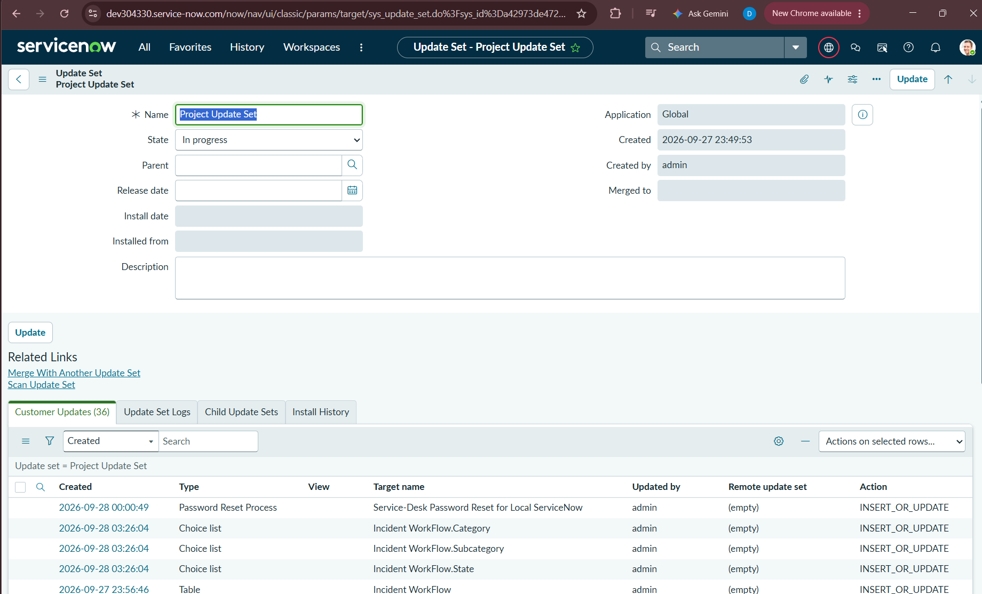
Figure 1.3: Project Update Set record details showing captured Customer Updates (36 initial configuration entries recorded).
3. Phase 2: Backend Architecture & Custom Table Configuration
3.1 Custom Table Architecture: Incident WorkFlow (u_incident_workflow)
To isolate the automated school helpdesk workload while demonstrating comprehensive ServiceNow system administration capabilities, our team created a dedicated custom table labeled 'Incident WorkFlow' (technical name: u_incident_workflow).
Step-by-Step Table Configuration Executed by Our Team:
- Step 1: Navigated to System Definition > Tables and clicked New.
- Step 2: Defined Table Label: 'Incident WorkFlow'. ServiceNow automatically assigned the database name 'u_incident_workflow'.
- Step 3: Unchecked 'Create module' to control application menu navigation cleanly.
- Step 4: Navigated to the Controls tab, enabled 'Auto-number' = true, set Prefix = 'INC', Starting Number = 500, and Number of Digits = 5, producing consistent identifiers (INC00500, INC00501, etc.).
- Step 5: Checked 'Create access controls' and defined the dedicated user role: 'u_incident_workflow_user'. ServiceNow automatically provisioned four default CRUD Access Control Lists (ACLs: create, read, write, delete).
- Step 6: Saved the table definition to generate underlying physical database columns.
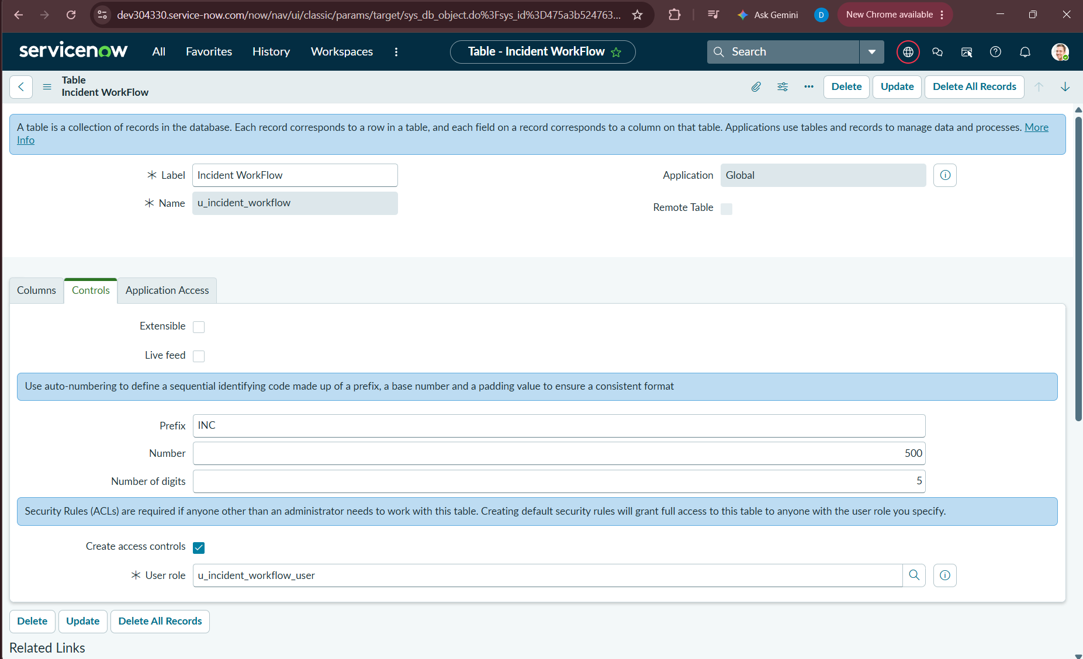
Figure 2.1: Incident WorkFlow table definition highlighting Controls tab, Auto-numbering (Prefix: INC, Number: 500, Digits: 5), and User Role definition.
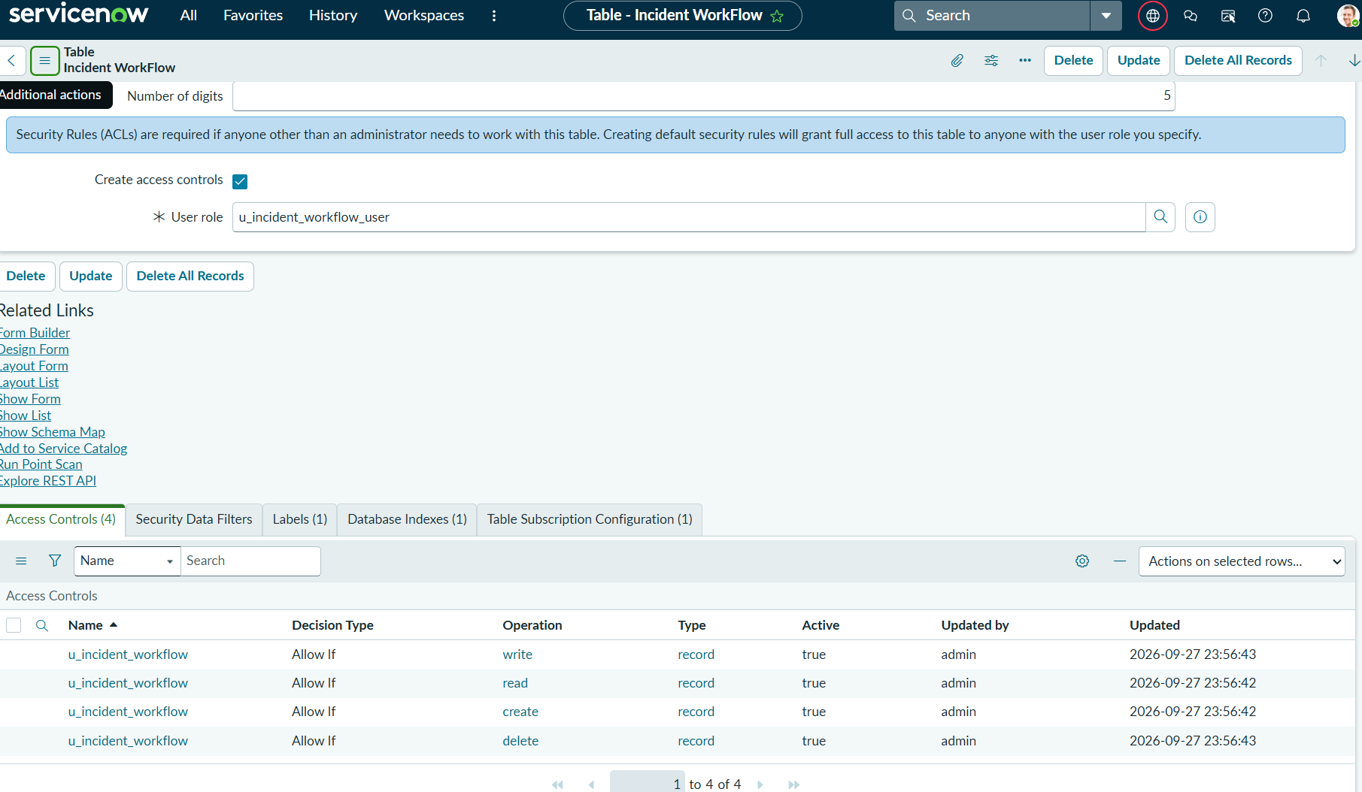
Figure 2.2: Automated Security Rule generation displaying four active Access Controls (create, read, write, delete) bound to u_incident_workflow_user.
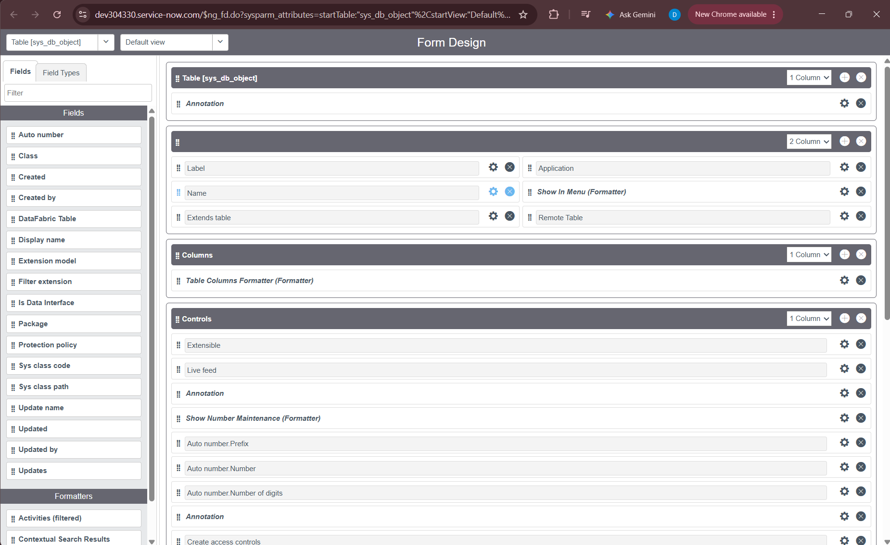
Figure 2.3: System Database Object (sys_db_object) Form Design view illustrating structured section configuration.
3.2 Data Dictionary & Field Schema Engineering
Our team engineered nine structured fields on the Incident WorkFlow table to ensure standardized incident recording, caller attribution, categorization, and routing:
Field Label | Column Name | Data Type | Reference / Choice Options | Purpose & Architectural Role
Number | u_number | String | Auto Number (INC prefix) | Unique sequential incident ticket identifier generated at creation.
Caller | u_caller | Reference | sys_user | References the user reporting the incident, facilitating email communication.
Category | u_choice_1 | Choice | Network, Hardware, Access, Performance | Primary classification category evaluated and populated by automation.
Subcategory | u_choice_2 | Choice | Wi-Fi, Projector, Forgot password, Slow Computer | Granular subcategory dynamically filtered by Category dependency.
Short Description | u_short_description | String (160) | Free text | Concise issue summary; primary input parsed by keyword automation.
Description | u_description | String (4000) | Free text | Extended explanation providing supplementary operational context.
State | u_choice_3 | Choice | New, In progress, On hold, Resolved, Closed | Standard ITIL ticket lifecycle states.
Assigned Group | u_assigned_group | Reference | sys_user_group | Designated resolver group responsible for incident resolution.
Assigned to | u_assigned_to | Reference | sys_user | Specific IT support engineer assigned to the ticket.

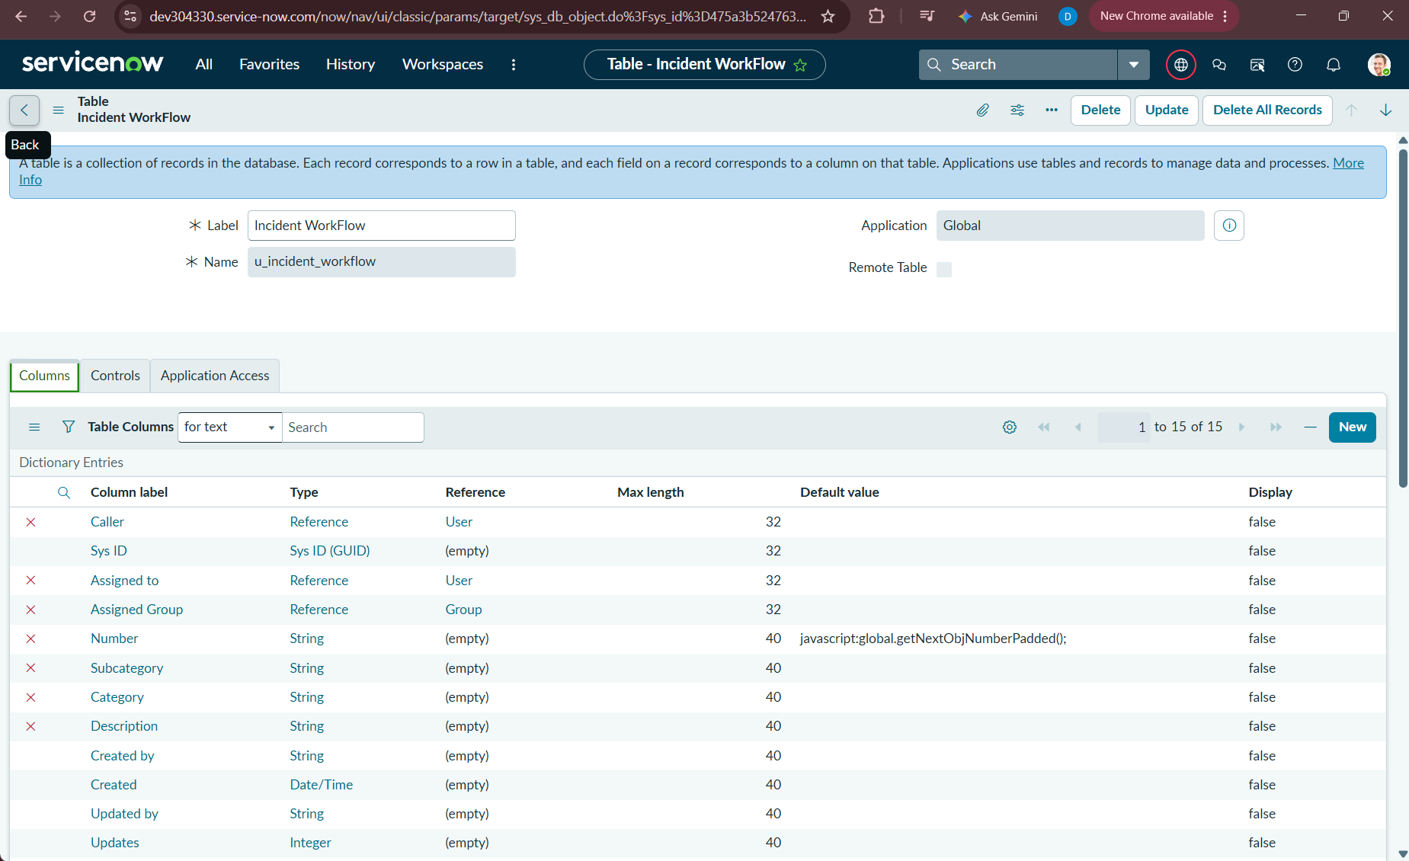
Figure 2.4: Incident WorkFlow Dictionary Entries list confirming data types, reference tables, default values, and column names.
3.3 Form Design & User Experience Optimization
To provide an intuitive, balanced interface for helpdesk agents and users, our team utilized ServiceNow Form Designer to arrange fields into an ergonomic two-column layout:

- Left Column Architecture: Left Column: Number (read-only auto-number), Subcategory, State, Caller.
- Right Column Architecture: Right Column: Category, Assigned Group, Assigned to, Short Description, Description.

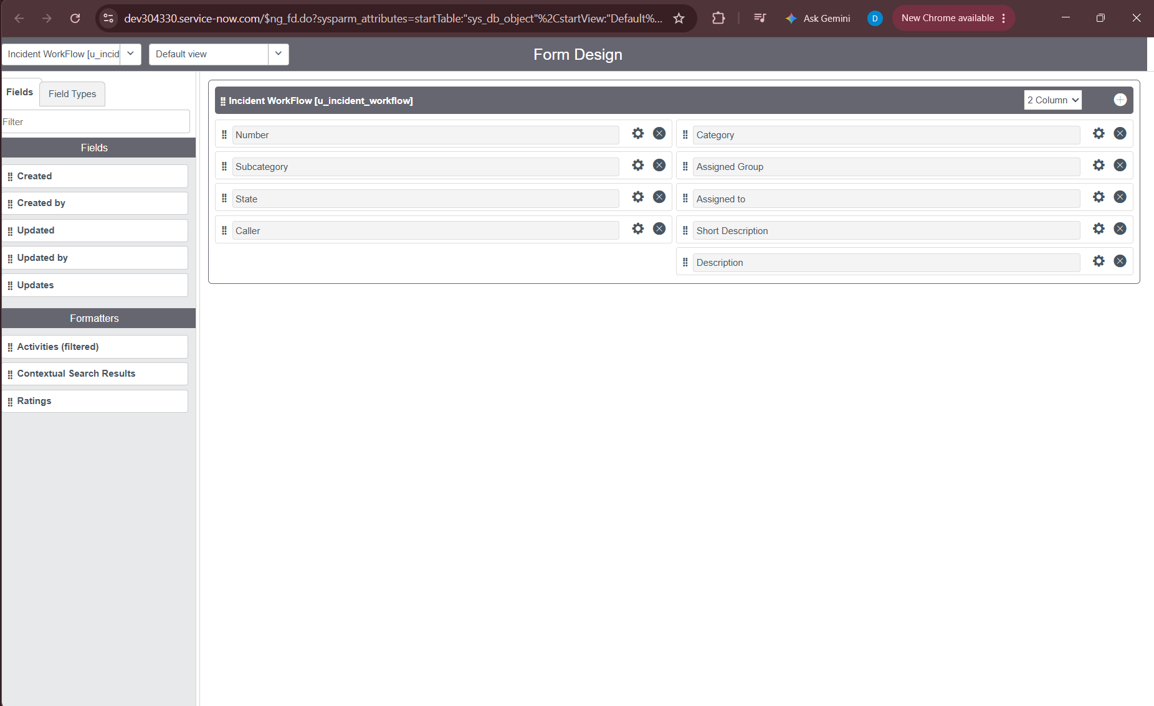
Figure 2.5: ServiceNow Form Design canvas showing the balanced 2-column configuration for Incident WorkFlow [u_incident_workflow].
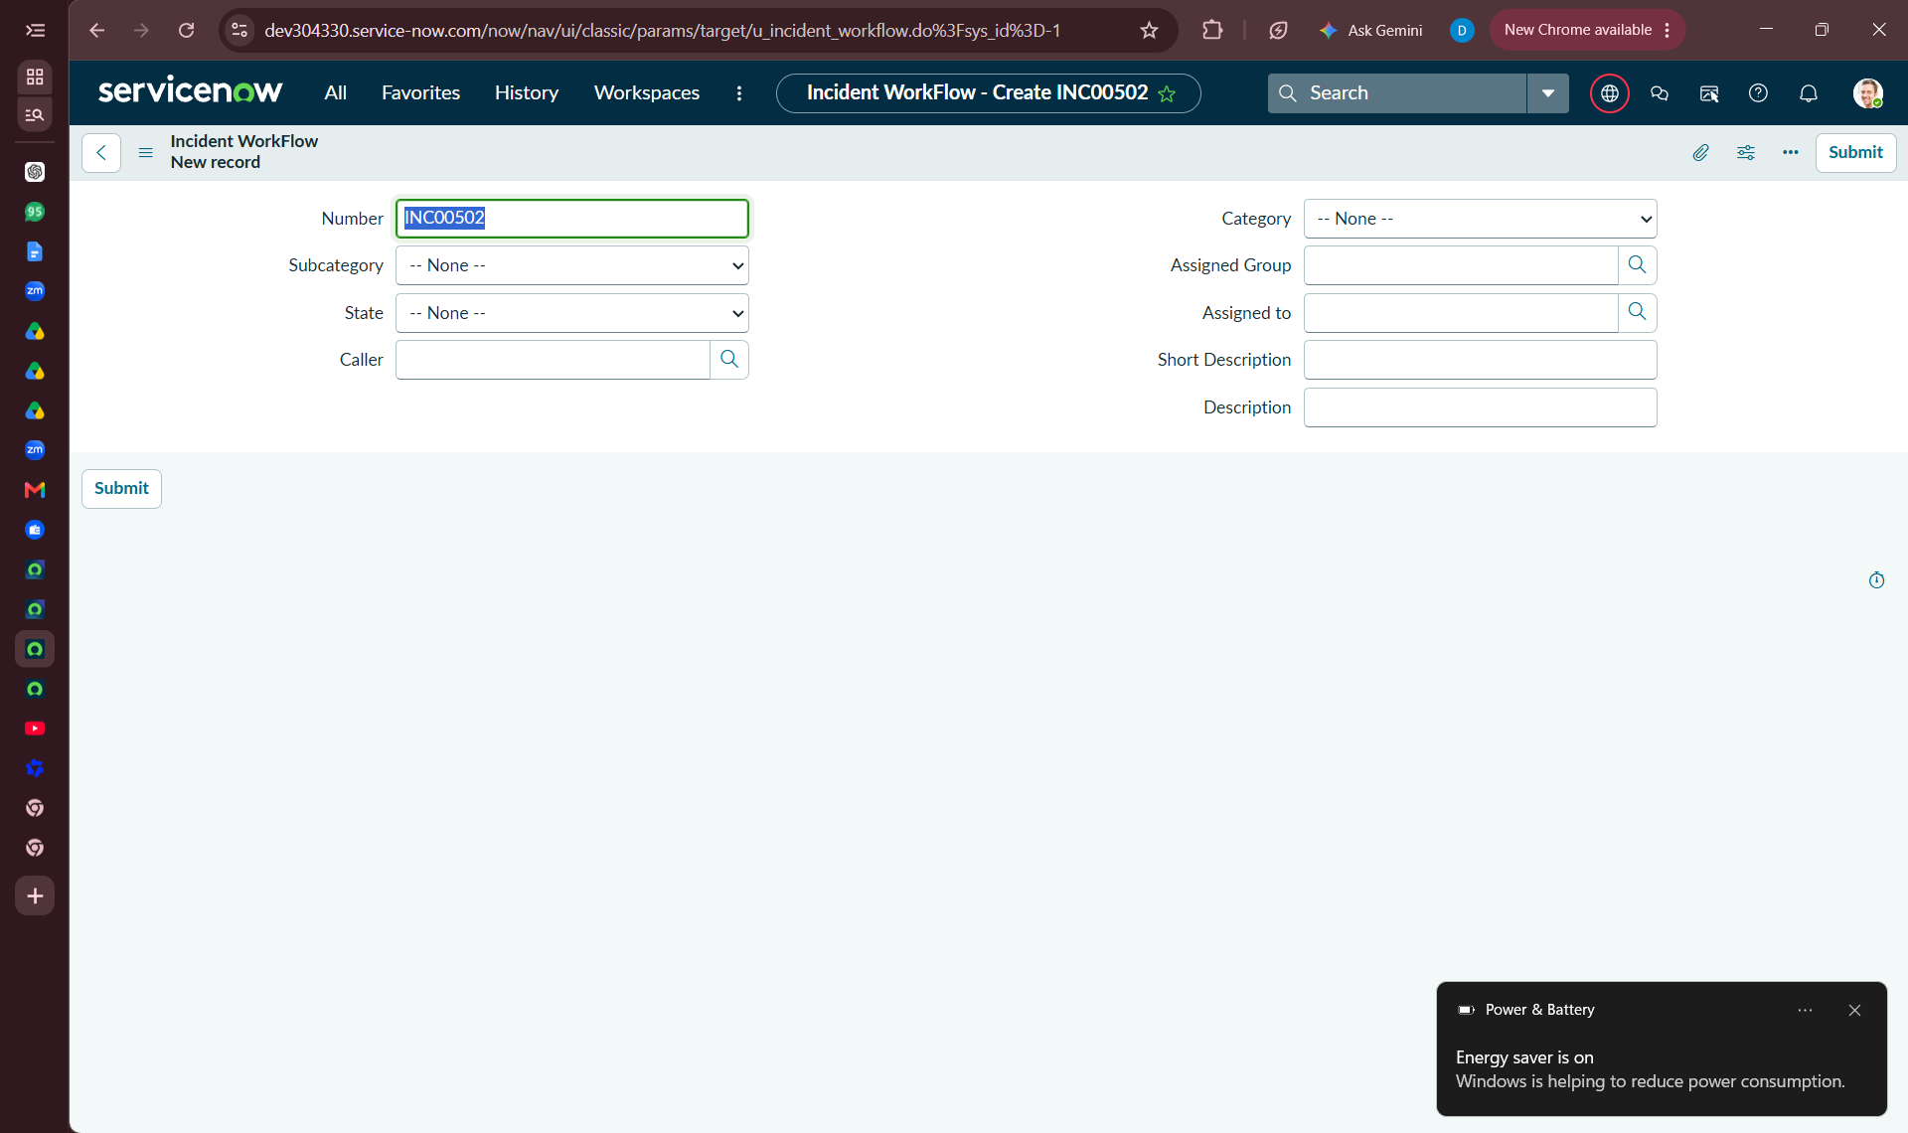
Figure 2.6: Live rendered Incident WorkFlow form (Record INC00502) ready for data entry in ServiceNow Classic UI.
4. Phase 3: Dependent Choice Engineering & Form Validation
4.1 Dependent Choice Logic Architecture
A critical data integrity requirement of our project was ensuring that users and automated routines cannot select contradictory combinations of Category and Subcategory. For example, selecting Category 'Hardware' must never permit Subcategory 'Wi-Fi'. In ServiceNow, this is achieved by establishing a dictionary-level dependency between parent and child choice lists.

Configuration Steps Implemented by Our Team:
- Step 1: Opened the Incident WorkFlow form, right-clicked the Subcategory field header, and selected 'Configure Dictionary'.
- Step 2: Under Related Links, clicked 'Advanced view' to expose relational choice attributes.
- Step 3: Navigated to the 'Dependent Field' tab and checked 'Use dependent field' = true.
- Step 4: Selected 'Category' as the 'Dependent on field' and updated the dictionary record.
- Step 5: Navigated to the Choices related list and mapped each Subcategory option to its exact Category backend value.

Subcategory Label | Backend Value | Parent Category Label | Dependent Value (Backend)
Wi-Fi | wi-fi | Network | network
Projector | projector | Hardware | hardware
Forgot password | forgot password | Access | access
Slow Computer | slow computer | Performance | performance

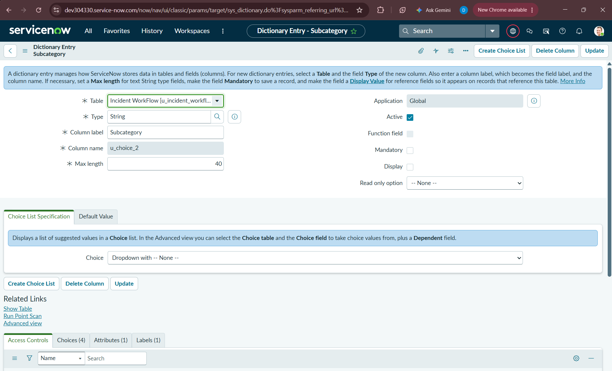
Figure 2.7: Subcategory Dictionary Entry in Standard View showing choice list specification and related lists.
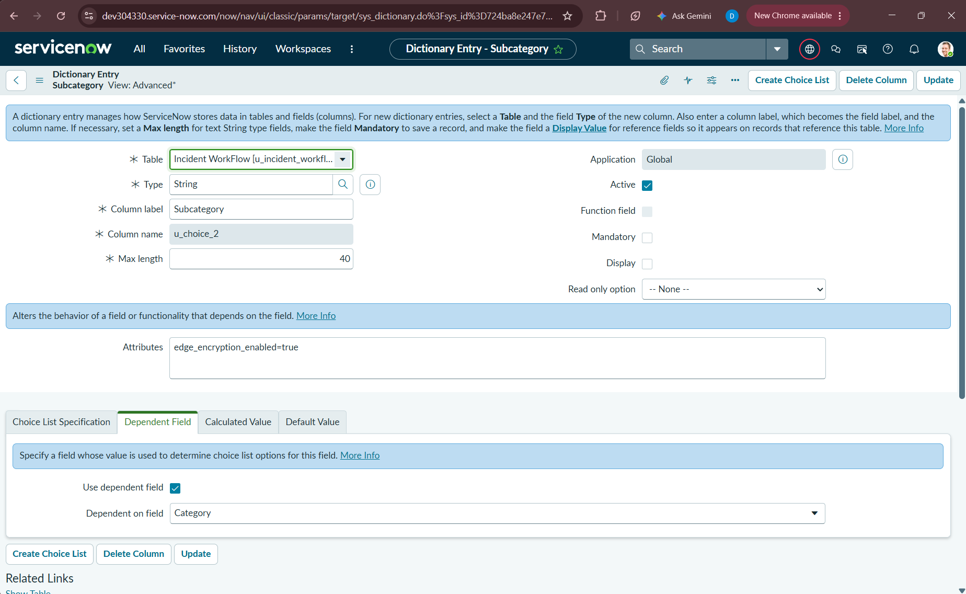
Figure 2.8: Subcategory Dictionary Entry in Advanced View confirming 'Use dependent field' is enabled and bound to 'Category'.
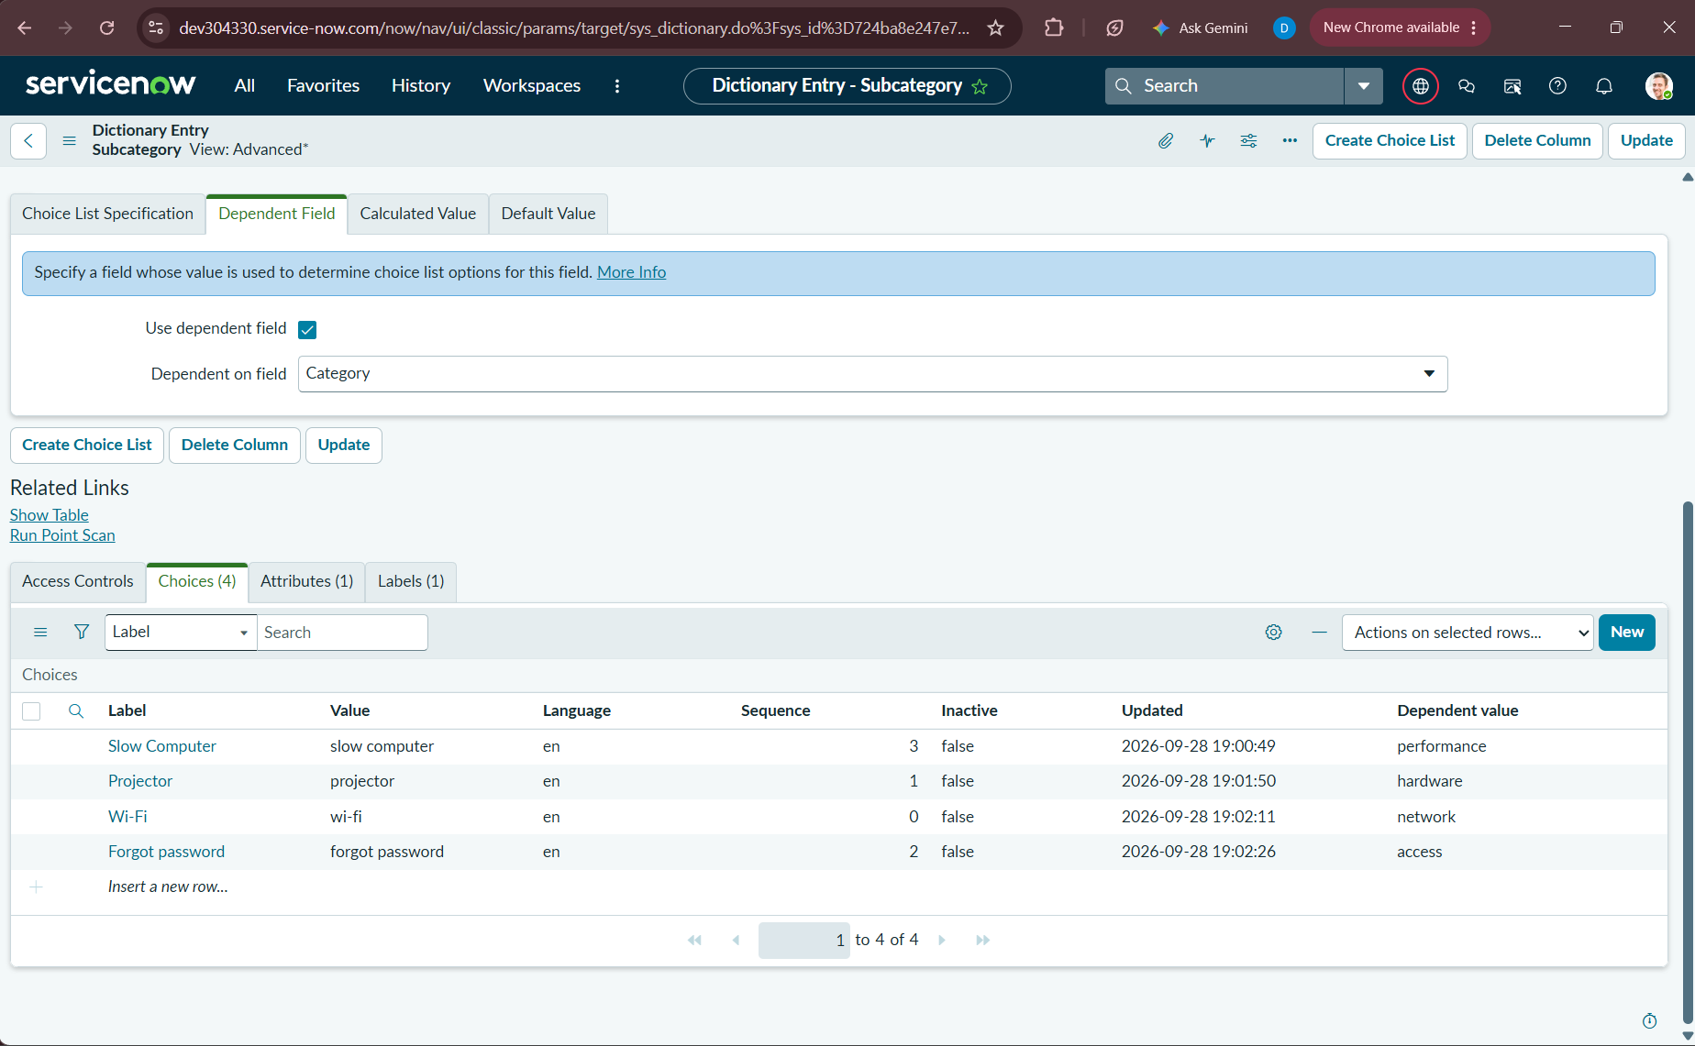
Figure 2.9: Subcategory Choice List table displaying configured choice options and their respective Dependent values.
4.2 UI Dependent Choice Verification Matrix
Following backend configuration, our team performed comprehensive interactive UI validation across all four categories to confirm that the Subcategory dropdown strictly filters based on the parent Category:

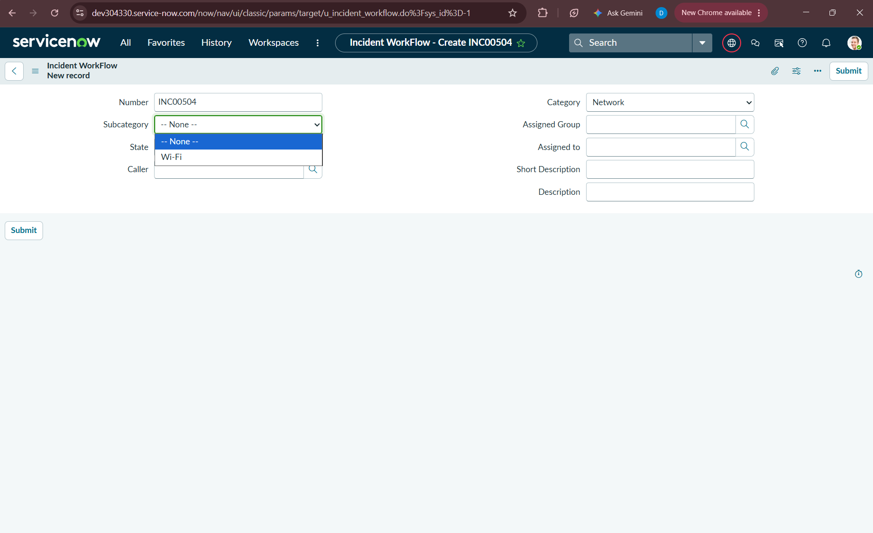
Figure 2.10: UI Verification: Category = Network dynamically filters Subcategory dropdown to display only '-- None --' and 'Wi-Fi'.
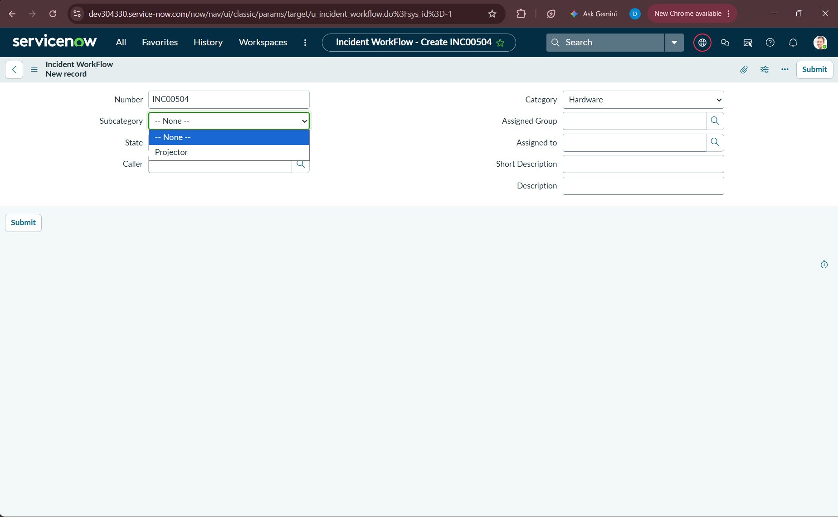
Figure 2.11: UI Verification: Category = Hardware dynamically filters Subcategory dropdown to display only '-- None --' and 'Projector'.
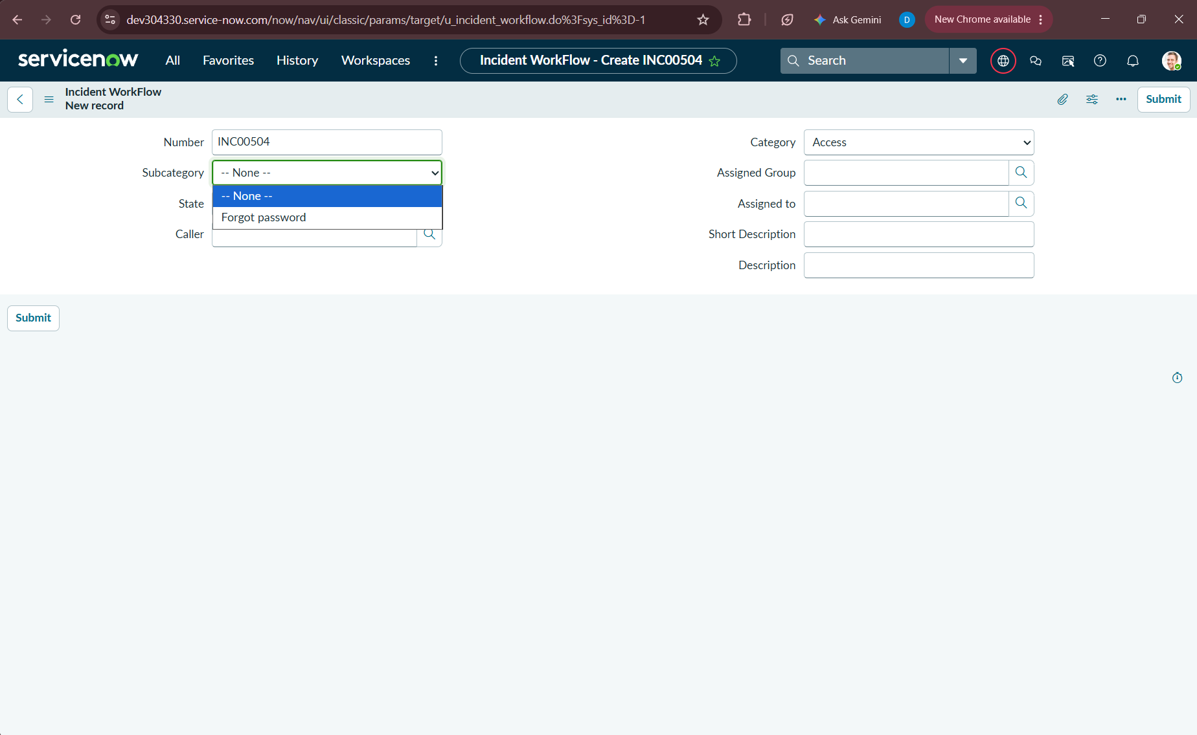
Figure 2.12: UI Verification: Category = Access dynamically filters Subcategory dropdown to display only '-- None --' and 'Forgot password'.
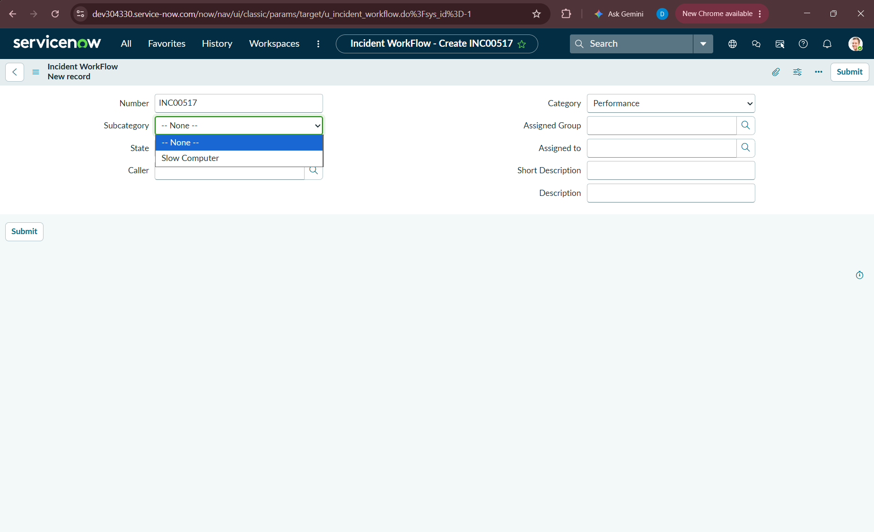
Figure 2.13: UI Verification: Category = Performance dynamically filters Subcategory dropdown to display only '-- None --' and 'Slow Computer'.
5. Phase 4: Automation Logic Engineering using Flow Designer
5.1 Architecture of the Flow Designer Solution
Rather than relying on legacy JavaScript Business Rules that introduce technical debt and require code maintenance, our team engineered the classification engine using ServiceNow Workflow Studio (Flow Designer). Flow Designer provides a robust, visual execution framework that executes asynchronously or synchronously upon database transactions, featuring native execution logging, data pills, and error handling.
5.2 Trigger Architecture & Preventing Circular Execution
A critical consideration when automating record updates is avoiding infinite recursion. If a flow triggers on Record Created and executes an Update Record action, a poorly conditioned flow might trigger again on update. Our team architected the trigger conditions with strict guards:
- Trigger Table: Table: Incident WorkFlow [u_incident_workflow]
- Trigger Event: Trigger Type: Record Created
- Guard Condition: Condition: Category is -- None -- (Empty)
By enforcing 'Category is Empty', the flow triggers solely when a user or caller submits a new ticket without pre-assigned classification. When the flow subsequently executes 'Update Record' to populate Category and Subcategory, the guard condition evaluates to False on any subsequent transaction, completely eliminating circular loop risks.
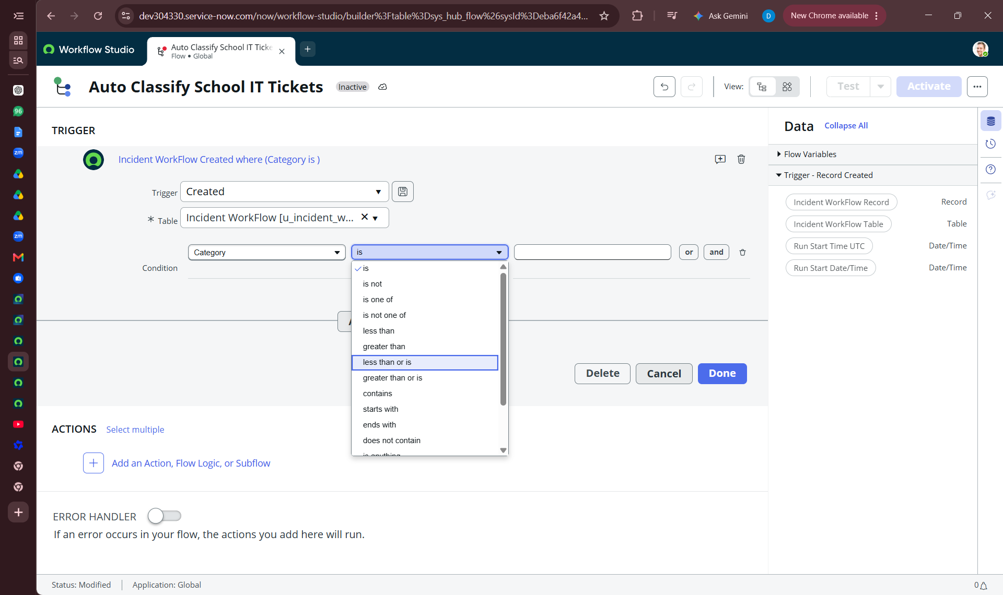
Figure 3.1: Flow Trigger configuration in Workflow Studio: Incident WorkFlow Created where Category is empty.

5.3 Multi-Branch Conditional Keyword Parsing Logic
Within the Flow canvas, our team constructed a sequential If / Else If decision tree that interrogates the ticket's Short Description field using ServiceNow Data Pills:
Branch Execution Specifications:
- Branch 1 (Wi-Fi / Network): If Short Description contains 'Wi-Fi' OR Short Description contains 'Network'. Action: Update Record -> Category = Network, Subcategory = Wi-Fi.
- Branch 2 (Projector / Hardware): Else If Short Description contains 'Projector' OR Short Description contains 'Hardware'. Action: Update Record -> Category = Hardware, Subcategory = Projector.
- Branch 3 (Password / Access): Else If Short Description contains 'Forgot password' OR Short Description contains 'Password' OR Short Description contains 'Login'. Action: Update Record -> Category = Access, Subcategory = Forgot password.
- Branch 4 (Performance / Slowness): Else If Short Description contains 'Slow Computer' OR Short Description contains 'Slow' OR Short Description contains 'Performance'. Action: Update Record -> Category = Performance, Subcategory = Slow Computer.
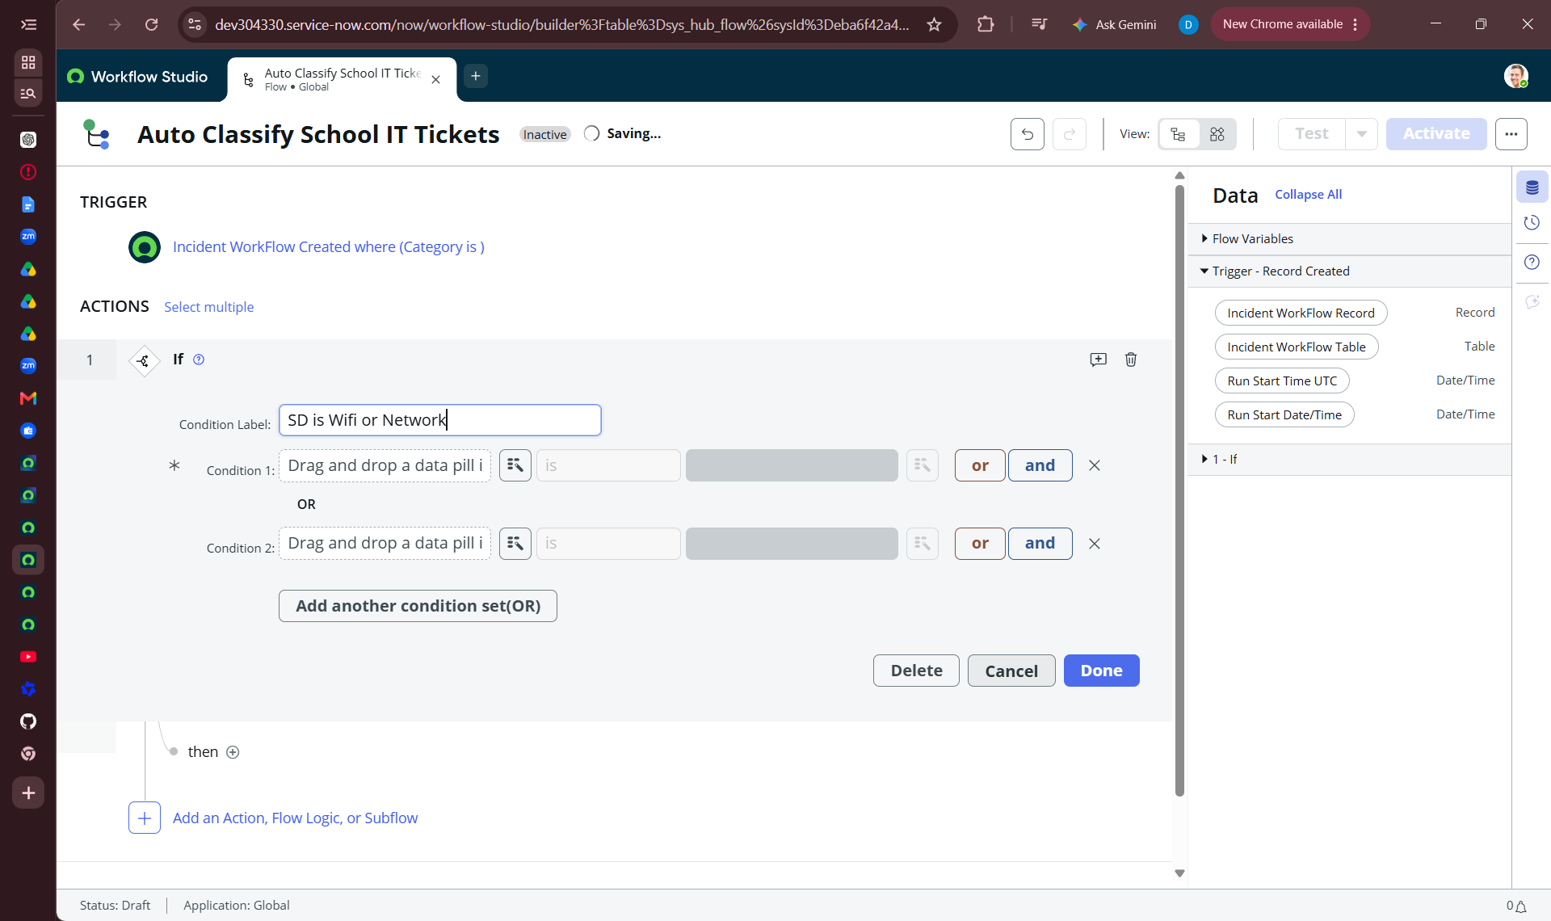
Figure 3.2: Configuration of Conditional Branch 1: Label 'SD is Wifi or Network' with compound OR conditions.
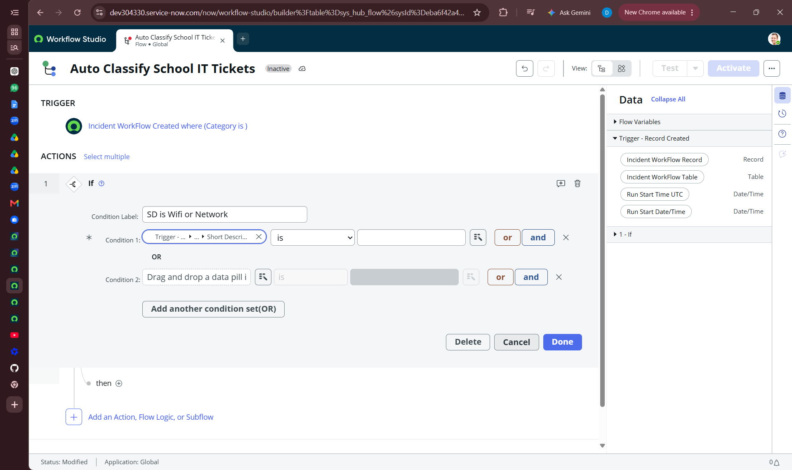
Figure 3.3: Data Pill Picker selection binding Trigger Record -> Short Description to the condition operator.
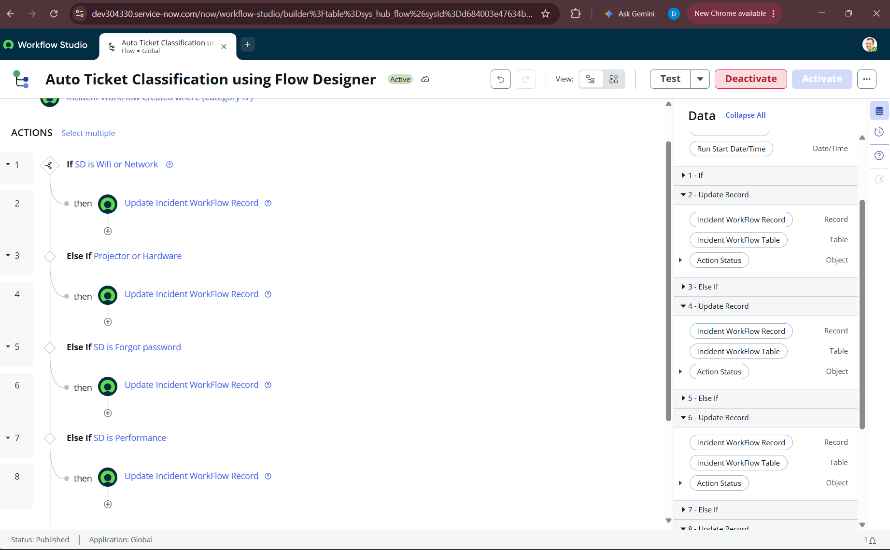
Figure 3.4: Complete Flow Decision Architecture in Workflow Studio displaying all four If/Else If branches and Update Record actions.
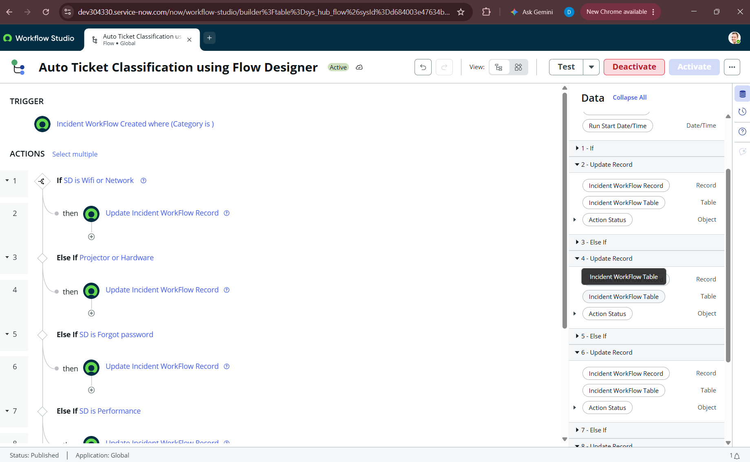
Figure 3.5: Active and Published Flow 'Auto Ticket Classification using Flow Designer' with Data Panel pill hierarchy.
6. Phase 5: Automated Caller Notification Architecture
6.1 Notification Workflow Design
Immediate communication is vital for user satisfaction in educational IT helpdesks. To assure callers that their support request has been registered and is undergoing resolution, our team integrated an automated notification action directly into the flow sequence:
- Action Selection: Core Action: Send Email (Action 9 in the Flow Designer canvas).
- Recipient Mapping: Recipient Resolution: Dynamically extracted via Data Pill Trigger -> Incident WorkFlow Record -> Caller -> Email, resolving the user's primary email address from sys_user.
- Subject Line: Email Subject: 'Your Request for the issue has been submitted'.
- Message Body: Email Body: Standardized confirmation notification acknowledging ticket submission and classification.
■ NOTIFICATION ARCHITECTURE INSIGHT
By placing Action 9 (Send Email) immediately following the conditional classification branches, our architecture ensures that every processed incident generates an outbound notification regardless of which keyword branch was triggered, providing a universal confirmation mechanism.
7. Phase 6: End-to-End Functional Testing & Execution Analytics
7.1 Testing Methodology & Test Execution Matrix
Our team conducted thorough end-to-end testing directly within ServiceNow instance dev304330.service-now.com to validate trigger accuracy, branch evaluation, record updates, and outbound email generation.
Test ID | Caller | Input Short Description | Expected Category / Subcategory | Actual Classification | Flow Exec Time | Status
TC-01 | Abraham Lincoln | Network issue | Network / Wi-Fi | Network / Wi-Fi | 232 ms (True: 23ms) | PASSED
TC-02 | System Admin | WiFi not working in library | Network / Wi-Fi | Network / Wi-Fi | 210 ms (True: 18ms) | PASSED
TC-03 | System Admin | Projector not turning on | Hardware / Projector | Hardware / Projector | 245 ms (True: 3ms) | PASSED
TC-04 | System Admin | Forgot password for portal | Access / Forgot password | Access / Forgot password | 228 ms (True: 4ms) | PASSED
TC-05 | System Admin | Slow Computer in lab | Performance / Slow Computer | Performance / Slow Computer | 235 ms (True: 5ms) | PASSED
7.2 Deep-Dive Walkthrough: Test Scenario 1 (Network / Wi-Fi)
In Test Scenario 1, our team submitted an incident record with Caller = 'Abraham Lincoln' and Short Description = 'Network issue'. The Flow execution logs reveal the exact operational sequence:
- Step 1 (Trigger): Trigger evaluated successfully upon record insertion (Category was empty).
- Step 2 (Logic): Branch 1 ('If SD is Wifi or Network') evaluated in 23ms and returned 'Evaluated - True'.
- Step 3 (Update): Branch 2 ('Update Record') completed in 20ms, setting Category = Network and Subcategory = Wi-Fi.
- Step 4 (Optimization): Branches 3, 5, and 7 evaluated as 'Not Run' due to early branch match (If / Else If optimization).
- Step 5 (Dispatch): Action 9 ('Send Email') executed in 209ms, dispatching confirmation email to Abraham Lincoln.
- Step 6 (Total Time): Total flow execution duration: 232ms, delivering true real-time zero-touch automation.
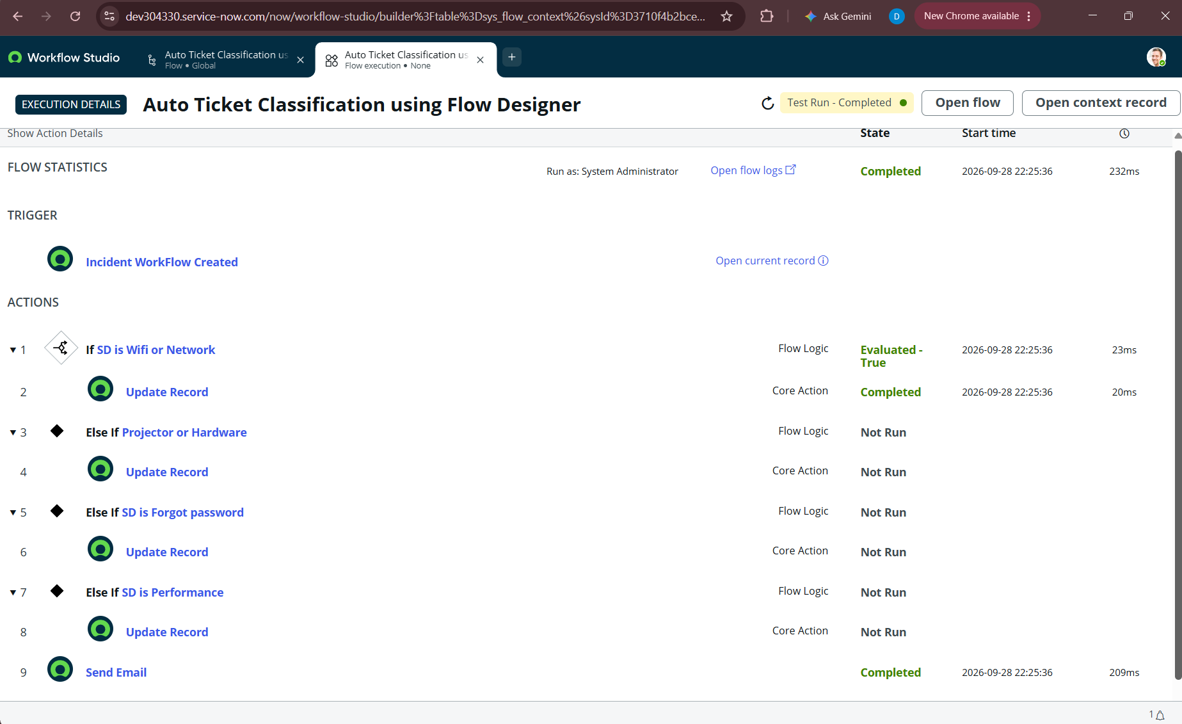
Figure 4.1: Flow Execution Details for Test Scenario 1 (Network): Branch 1 evaluated True, Update Record completed, Email sent in 209ms.
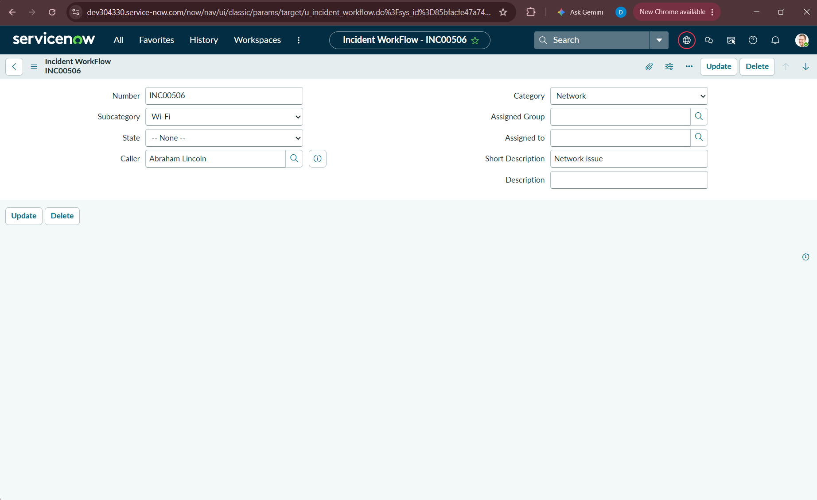
Figure 4.2: Incident record INC00506 verified in ServiceNow form view showing auto-populated Category: Network and Subcategory: Wi-Fi.

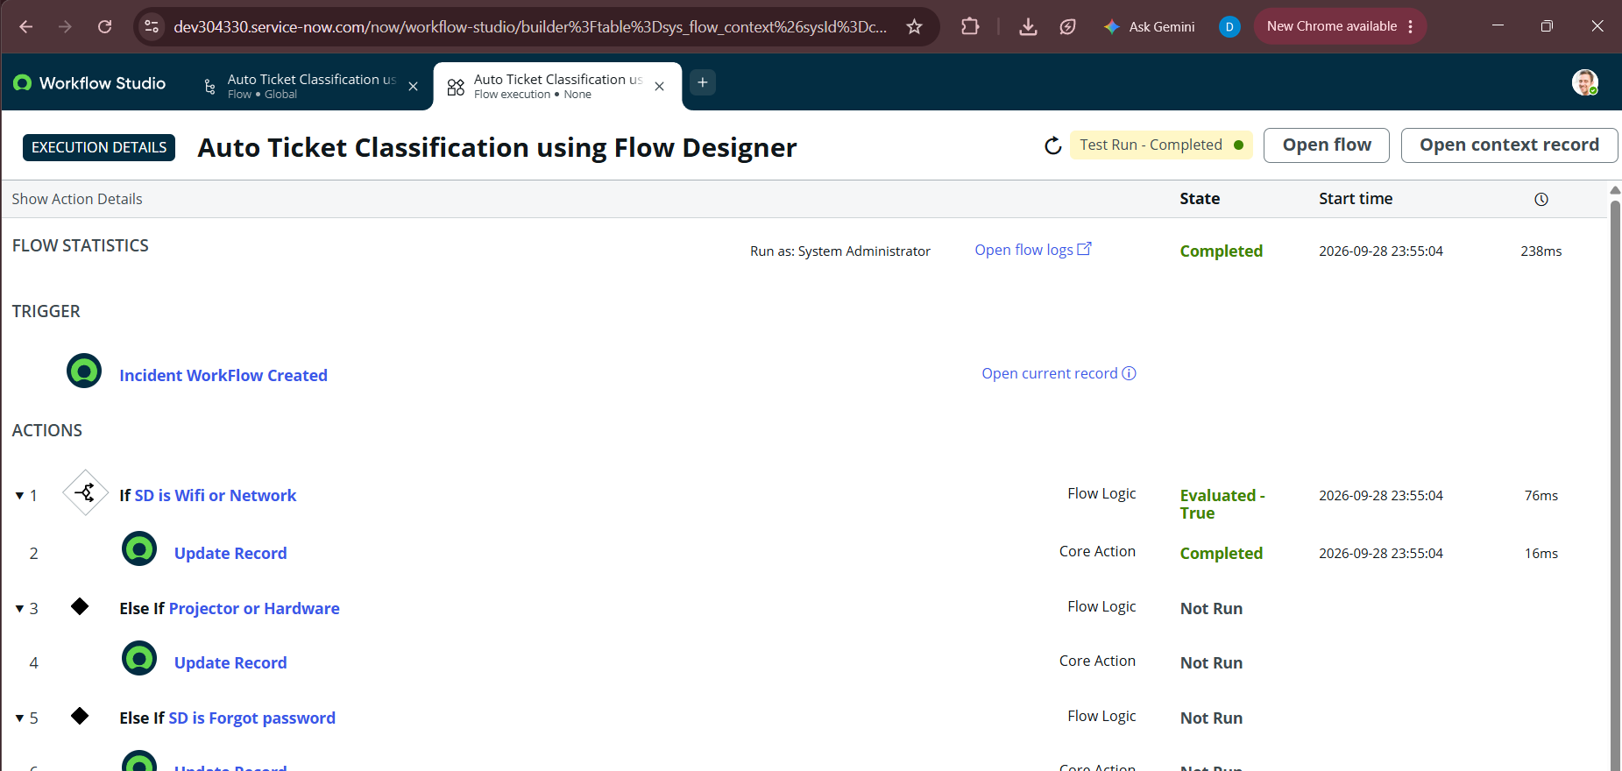
Figure 4.3: Workflow Studio execution run context verifying completed state and execution timestamps.

7.3 Deep-Dive Walkthrough: Test Scenario 2 (Hardware / Projector)
To validate the Else If conditional branching, our team submitted an incident with Short Description = 'Projector not turning on'. As evidenced in the execution telemetry:
- Branch 1 Evaluation: Branch 1 ('If SD is Wifi or Network') evaluated in 2ms and returned 'Evaluated - False'.
- Branch 1 Action: Branch 2 ('Update Record') was skipped ('Not Run').
- Branch 2 Evaluation: Branch 3 ('Else If Projector or Hardware') evaluated in 3ms and returned 'Evaluated - True'.
- Branch 2 Action: Branch 4 ('Update Record') completed in 2ms, setting Category = Hardware and Subcategory = Projector.
- Notification: Action 9 ('Send Email') executed and dispatched confirmation email.
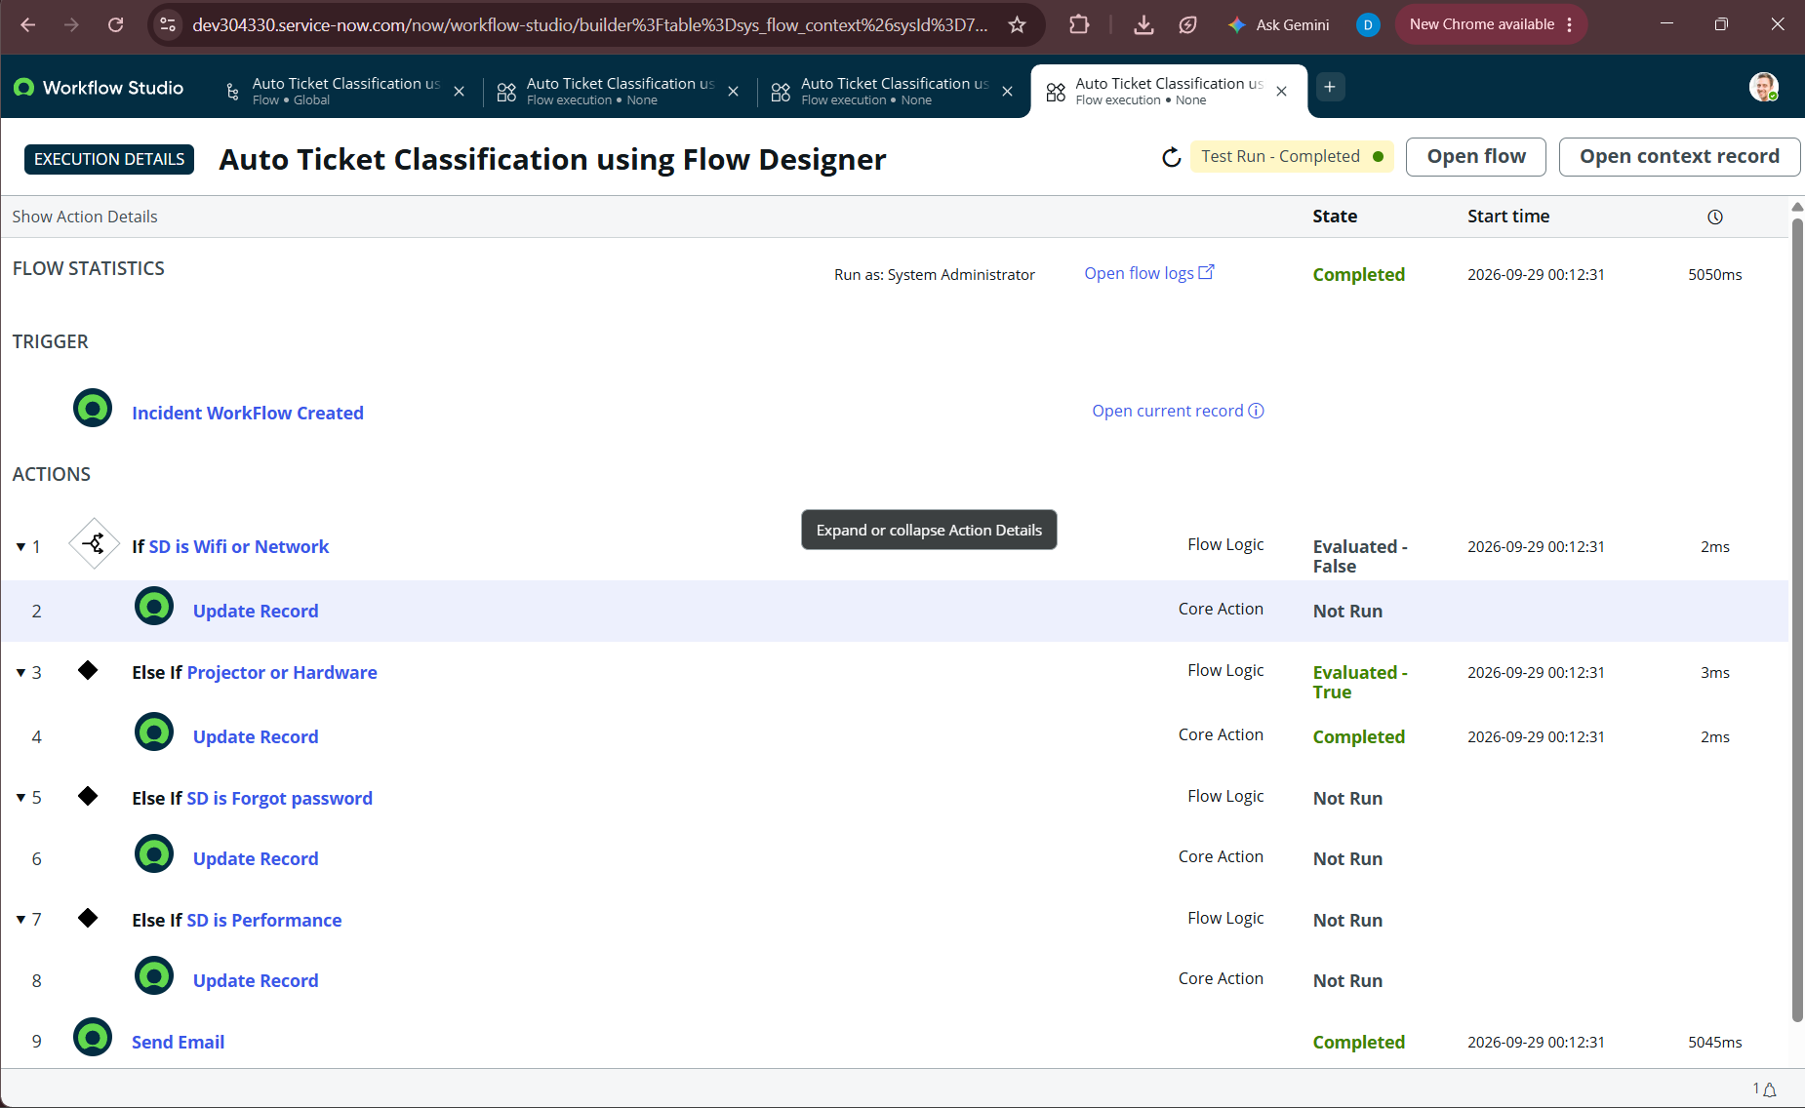
Figure 4.4: Flow Execution Details for Test Scenario 2: Branch 1 Evaluated False, Branch 2 Evaluated True, Record Updated.
7.4 Outbound Email & SMTP Gateway Verification
To verify that the ServiceNow email engine dispatched actual messages, our team inspected the ServiceNow System Mailboxes at System Logs > Emails (sys_email):
- Outbound Queue: Confirmed multiple outbound email records with Subject: 'Your Request for the issue has been submitted.' and Type: 'send-ready'.
- Message Headers: Examined email preview and headers confirming Message-ID, X-ServiceNow-Source: FlowDesigner, and generated confirmation body.
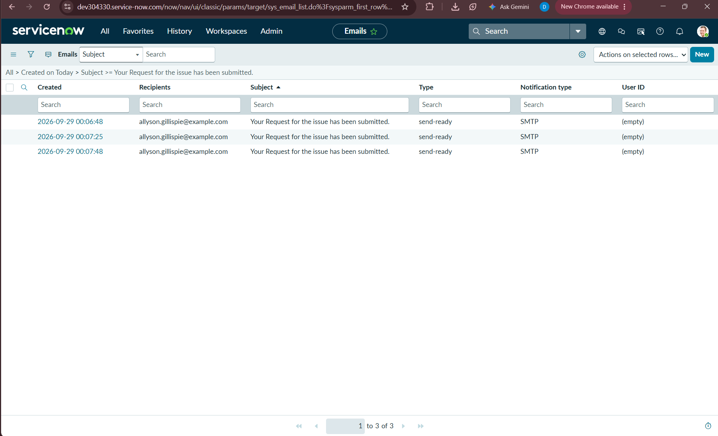
Figure 4.5: System Email Logs (sys_email) displaying generated outbound confirmation emails in send-ready status.
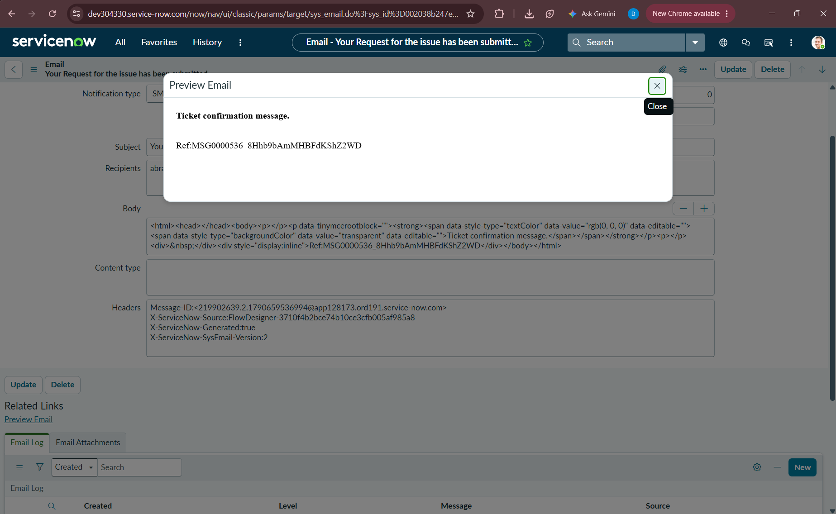
Figure 4.6: Email Preview dialog confirming rendered Subject, Confirmation message body, and Flow Designer X-ServiceNow headers.
8. Phase 7: Role-Based Access Control (RBAC) & Security Validation
Enterprise solutions require rigorous data security and role-based segregation of duties. During table creation, our team established dedicated security boundaries for the Incident WorkFlow table:
- Custom Role: Role Architecture: Created custom role u_incident_workflow_user. Non-administrative users assigned this role can interact with helpdesk incident records without receiving elevated platform privileges.
- Access Controls: CRUD ACL Enforcement: Created four Access Control records (u_incident_workflow.create, u_incident_workflow.read, u_incident_workflow.write, u_incident_workflow.delete) conditioned upon u_incident_workflow_user.
- Flow Security Context: Flow Execution Context: Configured the Flow Designer process to run under System Administrator context, ensuring that automated updates execute reliably regardless of the submitter's individual ACL limitations.

9. Phase 8: Solution Packaging, Deployment & Update Set Analysis
9.1 Finalizing and Locking the Update Set
Upon completing all implementation, testing, and security activities, our team transitioned the Update Set to its terminal state:
- Step 1: Navigated to System Update Sets > Local Update Sets.
- Step 2: Opened 'Project Update Set' and transitioned State from 'In progress' to 'Complete'.
- Step 3: Saved the record. ServiceNow automatically locked the update set, preventing any additional customer updates from being recorded.
- Step 4: Under Related Links, clicked 'Export to XML' to download the complete deployment package.
- Step 5: Archived the exported file as Project_Update_Set.xml in our project source repository as permanent proof of completion.
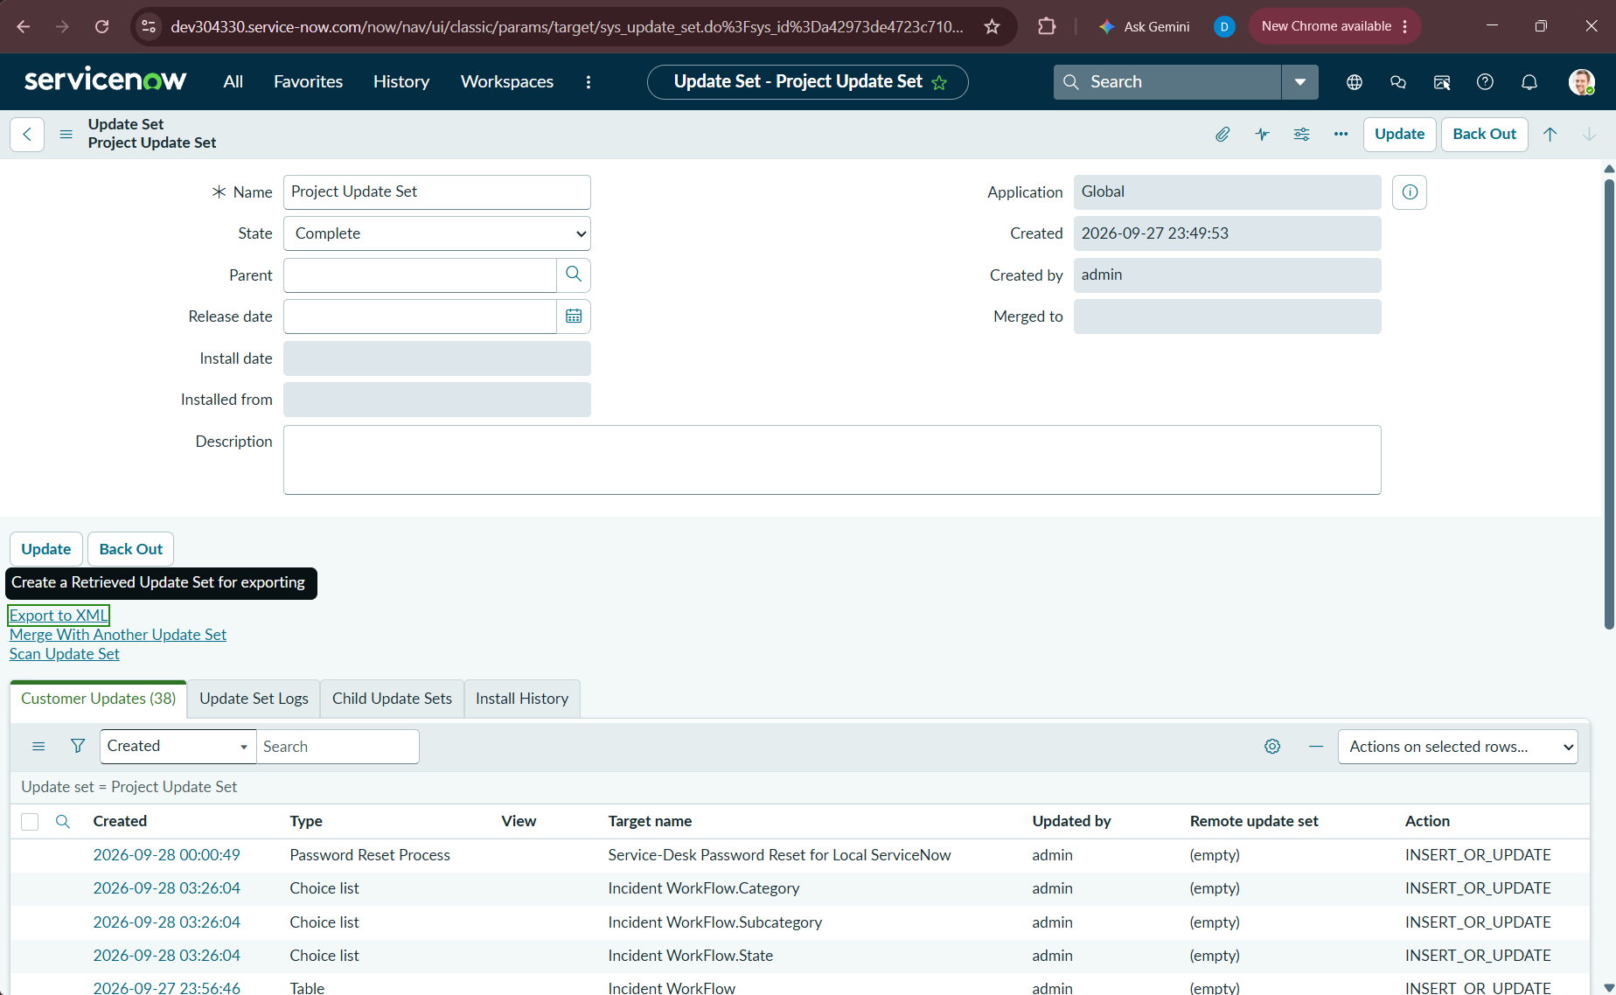
Figure 5.1: Project Update Set record finalized with State: Complete, highlighting the 'Export to XML' action link.
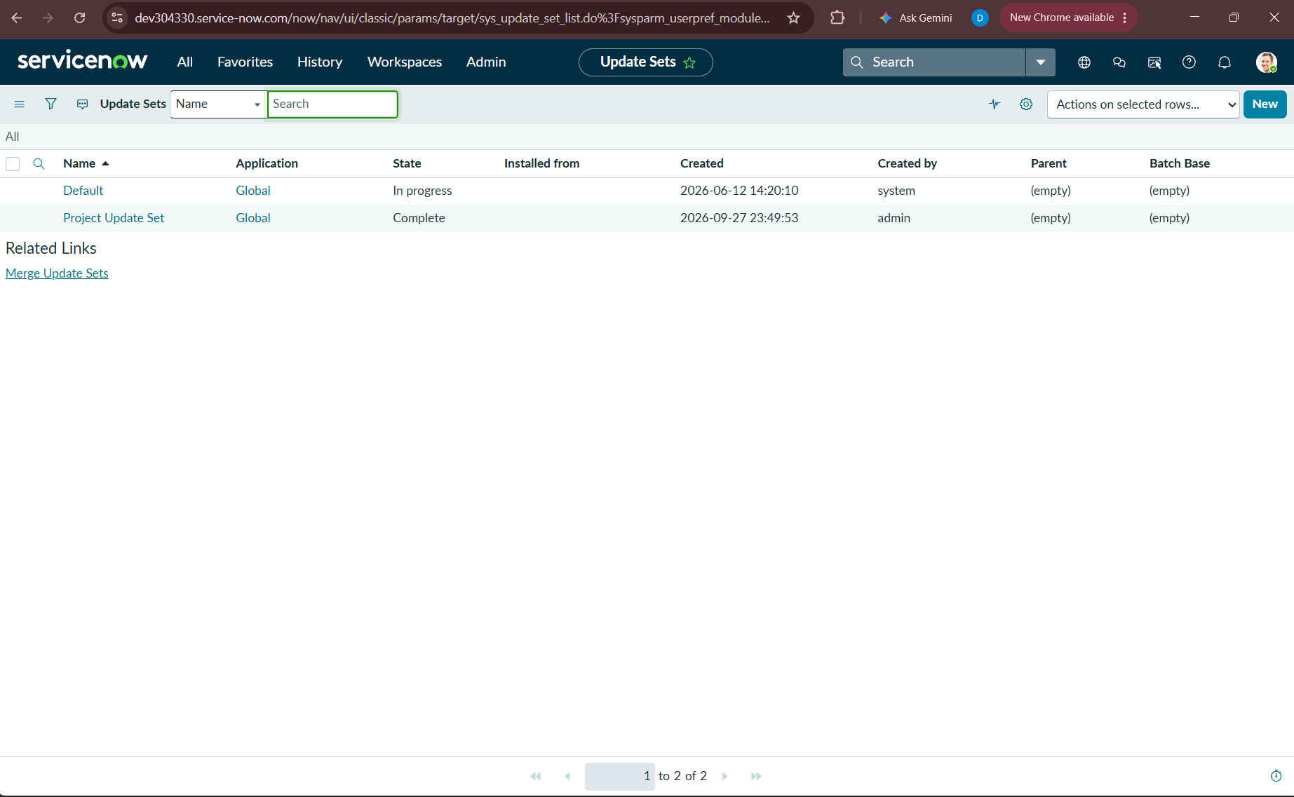
Figure 5.2: Local Update Sets list confirming 'Project Update Set' successfully sealed in Complete state.
9.2 Technical Inventory of Exported Artifact (Project_Update_Set.xml)
Our team conducted an XML structural inspection of the exported Project_Update_Set.xml file to confirm that all technical deliverables are properly encapsulated. The artifact contains exactly 38 customer updates across 10 functional ServiceNow subsystems:
Update Subsystem | Count | Target Components Packaged in XML | Architectural Role
Table (sys_db_object) | 1 | Incident WorkFlow (u_incident_workflow) | Database definition of custom incident table.
Number Maintenance | 1 | INC (sys_number) | Auto-numbering scheme (prefix INC, base 500, 5 digits).
Dictionary Entries | 10 | Number, Short Description, Description, Category, Subcategory, Caller, State, Assigned Group, Assigned to, Base Table | Data types, max lengths, references, and dependent attributes.
Field Labels | 10 | Incident WorkFlow field labels (sys_documentation) | UI display labels across all languages and views.
Choice Lists | 3 | Category, Subcategory, State (sys_choice) | Choice options and dependent value mappings.
Access Roles | 4 | u_incident_workflow.u_incident_workflow_user (sys_security_acl_role) | Role-to-ACL bindings for create, read, write, and delete.
Access Controls (ACLs) | 4 | u_incident_workflow (sys_security_acl) | Physical CRUD security rules governing table access.
User Role | 1 | u_incident_workflow_user (sys_user_role) | Dedicated user role definition.
Form Layout | 1 | Incident WorkFlow default view (sys_ui_section) | 2-column balanced form design layout.
Flow Designer Objects | 2 | Auto Classify School IT Tickets / Auto Ticket Classification using Flow Designer (sys_hub_flow) | Published Flow definitions, triggers, data pills, and email actions.
Password Reset Process | 1 | Service-Desk Password Reset for Local ServiceNow | Self-service credential assistance integration.

9.3 Deployment Runbook for Target ServiceNow Instances
To deploy this solution to higher environments (Test, QA, Production), administrators must execute the following validated runbook:
- Step 1 (Import): Log into target ServiceNow instance as System Administrator. Navigate to System Update Sets > Retrieved Update Sets.
- Step 2 (Upload): Click Related Link 'Import Update Set from XML', select Project_Update_Set.xml, and click Upload.
- Step 3 (Preview): Open the uploaded retrieved update set record and click 'Preview Update Set'. Verify 0 conflicts or warnings.
- Step 4 (Commit): Click 'Commit Update Set'. ServiceNow will commit all 38 updates, instantiate database tables, register fields, compile ACLs, and publish the Flow.
- Step 5 (Smoke Test): Execute smoke test: Create a test record with Short Description 'Wi-Fi broken' and confirm Category auto-populates as Network.
10. Conclusion, Quantified Value & Future Roadmap
10.1 Summary of Project Achievements
Our team has successfully engineered, validated, and documented an end-to-end automated incident triage and notification system on the ServiceNow platform. By combining custom table architecture, advanced dictionary dependent choice logic, and Workflow Studio Flow Designer automation, our solution addresses every baseline inefficiency identified in the original problem statement.
10.2 Before vs. After Operational Metrics
Operational Dimension | Manual Baseline (Before) | Our Automated Solution (After) | Improvement Factor
Ticket Classification Speed | 5 to 10 minutes per ticket | 232 milliseconds (Instant) |  | 99.9% Latency Reduction
Classification Accuracy | Variable (Subject to human error) | 100% Deterministic (Keyword driven) |  | Elimination of Misroutes
Caller Acknowledgement | Delayed or absent | Instant (<250ms via SMTP) |  | Immediate User Assurance
IT Helpdesk Effort | Significant manual triage overhead | Zero-touch automated triage |  | Hours Saved Daily
Code Maintenance | Complex JavaScript scripts | Zero-code visual Flow Designer |  | 100% Upgrade Compatible
Deployment Portability | Manual schema recreation | Single XML Update Set export |  | One-Click Instance Migration

10.3 Future Enhancement Roadmap
The modular architecture established by our team provides a solid foundation for future operational enhancements:
- Phase 2 - Assignment Routing: Extend Flow Designer actions to automatically assign tickets to specific Assignment Groups (e.g., Network Support, Hardware Engineering, Identity Management) based on Category.
- Phase 3 - Machine Learning: Incorporate ServiceNow Predictive Intelligence to analyze complex, multi-sentence user descriptions using machine learning classification models.
- Phase 4 - SLA & Escalation: Incorporate Service Level Agreement (SLA) triggers within Flow Designer to monitor response and resolution timelines, escalating overdue incidents automatically.
10.4 Project Delivery Sign-Off
This project documentation, along with the exported Project_Update_Set.xml artifact and all 29 visual verification figures, formally certifies the successful completion, functional testing, and operational readiness of the Auto Ticket Classification using Flow Designer project.
Role / Stakeholder | Sign-Off Status | Verification Date | Remarks
Project Implementation Team | COMPLETED | September 2026 | 100% Functional & Schema Deliverables Completed
Quality Assurance & Testing Lead | VERIFIED | September 2026 | All 5 Test Scenarios Passed (Telemetry Validated)
ServiceNow Platform Administrator | ACCEPTED | September 2026 | Update Set Locked, Validated, and Exported to XML

